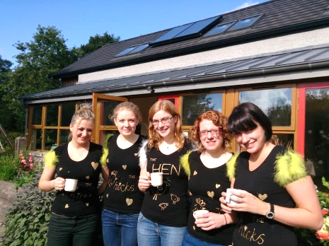
Orchard Acre Farm
Hen Parties

Looking to do something different?

Go somewhere a bit off the beaten track?

Create the best hen story like no other?

Our award-winning Eco farm is just the place.

Celebrate in the unique alternative, bohemian settings of our private eco farm; just minutes from Enniskillen Co Fermanagh. N Ireland. We offer exclusive use of our multiple award winning & very lovely Eco Barn, our orchards and kitchen gardens. Great in all weathers perfect Instagram moments.

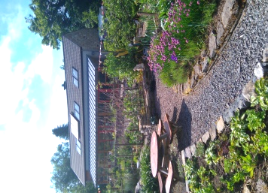
- Hen party activities tailored to suit each individual hen
- Teresa (the farmer) gives discreet attention to details all day
- Give your hen the best possible send-off.

Teresa, Hugh (hubby) and family have been farming here since 1989. They added their gorgeous eco barn to the farm in 2008 creating a magic space for groups who seek a private venue for the most special of occasions. Barn pictured in kitchen garden

From £29 * p/p

Teresa and her team pull out all the stops for hen parties. We work so that each flock has the right balance between genuine fun, quality time for engaging with fellow hens and learning a new skill. Our hen activities are memorable, classy and great fun.
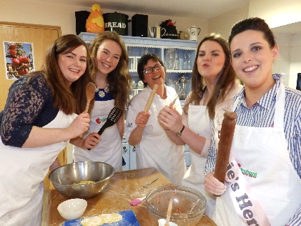

Vintage Afternoon Tea Vintage music/ games & bubbles £29
Dance classes £39
Cookery Classes £69
Craft workshops £59
Wine / Beer tasting £59
Natural cosmetics workshop and facials £79

A small booking fee secures date: We can help your find accommodation too.

More than 12 hens ?.......... then the bride’s activity will be COMPLETELY free! *

- Teresa (your farm host) gives lots of help to YOU the organiser!
- Highly skilled and fun-loving tutors.
- Make staggered payments online; helping to avoid bistro economics.
- Award winning Farm and Farm fresh foods. AND easy to get to.
- There is a fabulous range of accommodation locally. We can organise transfers.
- Best private dining experience Fermanagh has to offer.
- Private bar arrangements if required

